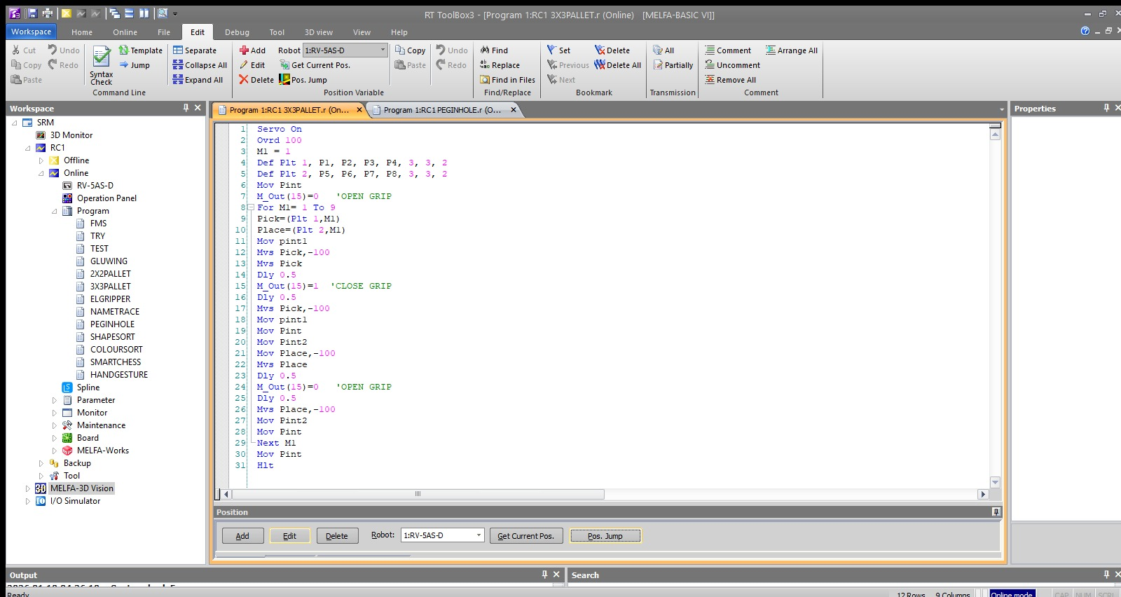
Figure 1: Program editor showing palletizing operation sequence.

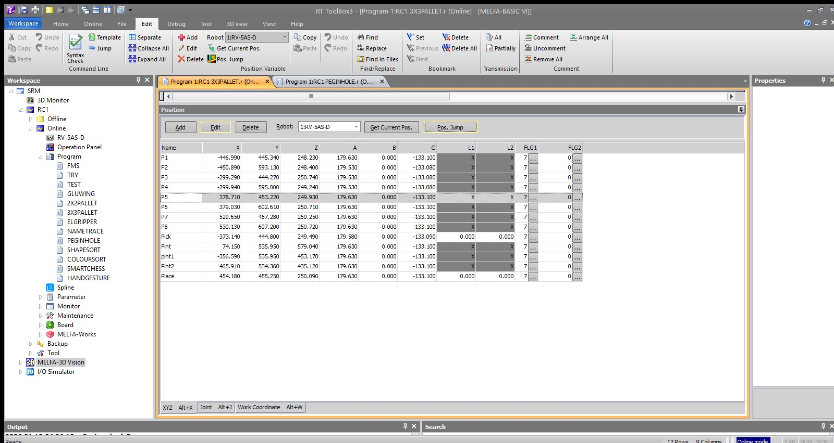
Figure 2: Position variables defining source and destination grid layout.
Expt No:  07 | DUAL-GRID SYNCHRONIZATION AND SEQUENTIAL ROUTING LOGIC
Date:
07 / 04 /2026

- AIM:
To design and implement an automated inter-array transfer sequence that retrieves workpieces from a saturated 3x3 source matrix and systematically populates an empty 3x3 destination matrix utilizing a deterministic routing algorithm and intermediate safety nodes.

- APPARATUS REQUIRED:
  - Robotic System: Mitsubishi RV-8CRL-D industrial manipulator.
  - Control Hardware: CR800-Series Controller and Teaching Pendant.
  - Software Suite: RT ToolBox3 integrated engineering environment.
  - Infrastructure: Precision-machined workspace table featuring two distinct 9-point (3x3) pallet grid fixtures (Source Grid and Destination Grid).
  - End-of-Arm Tooling (EOAT): Two-finger parallel pneumatic gripper actuated via Output 15.

- THEORY:
- Core Principle:
Inter-array manipulation requires the simultaneous management of multiple localized coordinate systems. The manipulator must dynamically calculate both a retrieval node and a placement node during each operational cycle, ensuring geometric synchronization between the two physical grids while avoiding lateral collisions.
- Working Mechanism:
  - Dual Pallet Definition: The system utilizes two independent Def Plt commands to map the Source (Pallet 1, using points P1-P4) and Destination (Pallet 2, using points P5-P8) matrices.
  - Routing Algorithm (Pattern 2): By setting the final parameter in the Def Plt syntax to 2, the controller's internal algorithm is forced to execute a specific non-standard deterministic sequence (e.g., zig-zag or columnar priority) across the 3x3 array, optimizing joint travel between indexing cycles.
  - Intermediate Trajectory Nodes (PInt): To safely navigate the physical space between the two separated grid plates without shearing the workpieces, the trajectory logic utilizes fixed intermediate waypoints (PInt, pInt1, PInt2). The robot must pass through these safe vertical clearance zones during every transfer.
- Key Formula:
During each cycle index ($M_1$), the system calculates two distinct spatial coordinates simultaneously:
Pick = (Plt 1, M1)
Place = (Plt 2, M1)

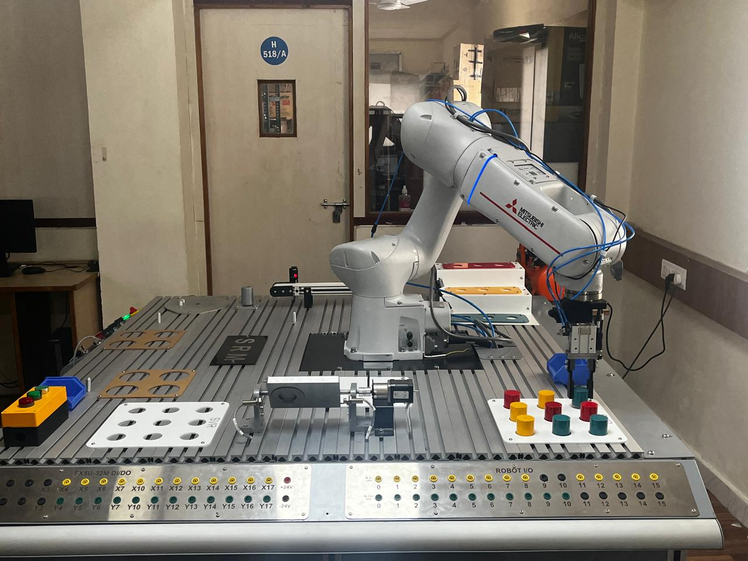
Figure 3: Manipulator performing workpiece pick from source grid.

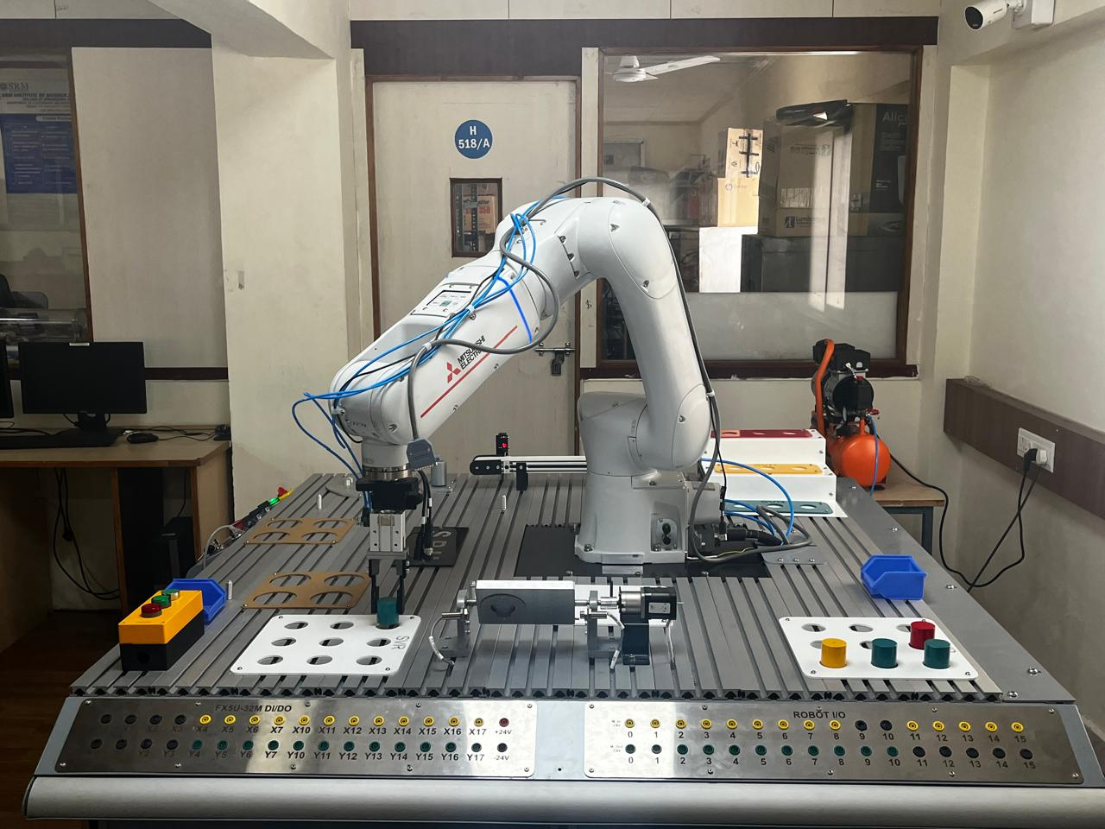
Figure 4: Manipulator performing workpiece placement in destination grid.
- PROCEDURE:
  - Setup & Connections:
Ensure pneumatic pressure is supplied to the parallel gripper. Secure the red cylindrical workpieces in the 3x3 source grid. Using the teaching pendant, define the absolute boundary coordinates for Pallet 1 (P1 to P4) and Pallet 2 (P5 to P8). Critically, teach the safe intermediate clearance waypoints (PInt, pInt1, PInt2) high above the workspace.
  - Algorithm & Logic:
    - Initialize both 3x3 arrays using Def Plt with pattern type 2.
    - Move to the global safe intermediate point (PInt) and ensure the gripper is open (M_Out(15)=0).
    - Initiate a For...Next loop to index from 1 to 9.
    - Retrieve: Calculate the Pick and Place coordinates. Move to the source-side intermediate point (pInt1), execute a vertical approach (-100mm), close the gripper to secure the workpiece, and retract vertically.
    - Transfer: Navigate back through pInt1 and the master safe point PInt to the destination-side intermediate point (PInt2).
    - Place: Execute a vertical approach (-100mm) to the Place coordinate, open the gripper, and retract vertically.
    - Iterate: Loop the process via Next M1 until all 9 objects are transferred, then return to PInt and halt.
  - Execution Steps:
    - Validate the physical coordinate registries for both pallets and all intermediate points in RT ToolBox3.
    - Execute a Step Run in manual mode to verify that the spatial translation between pInt1, PInt, and PInt2 maintains sufficient Z-axis clearance over the grid hardware.
    - Set Override speed to 100% (Ovrd 100) as defined in the program, and initiate Automatic mode execution.
  - Observation Instructions:
Visually monitor the kinematic sequence to confirm that the Pattern 2 parameter dictates the expected routing path across the grids. Observe the strict adherence to the intermediate routing nodes (PInt), ensuring no lateral sheer forces occur during the inter-array transfer.

- RESULT AND OBSERVATION:
The system successfully executed the automated inter-array transfer between two distinct 3x3 storage grids. The implementation of the zig-zag routing algorithm optimized joint travel time, and the synchronized dual-coordinate calculations maintained strict positional accuracy throughout the sequence, as verified by faculty.

